QA Tools Training Program – Assignment
Module 3 – Automation Tools – 1
Assignment 1 – Cypress Debuggingo
The following Cypress test fails randomly:
cy.visit("/login")
cy.get("#username").type("admin")
cy.get("#password").type("Cisco123")
cy.get("#login").click()
cy.get("#dashboard").should("be.visible")
Answer:
- List four possible reasons for the intermittent failure.
- How would you debug the issue?
- How would you improve the script to make it more stable?
- What additional validations would you include?
Assignment 2 – pyATS Automation
Develop a pyATS script that:
- Connects to at least three devices (real or simulated).
- Executes:
  - show version
  - show inventory
- Parses the output.
- Generates an HTML or CSV report.
Include proper exception handling.

assignment2_pyats.py:
"""
Assignment 2 – pyATS Automation Script
Performs network device audit (connects to 3 devices, runs 'show version' & 'show inventory',
parses output, handles exceptions, and generates a CSV/HTML report).
"""

import csv
import re
import os

# --- 1. SIMULATED DEVICES & CLI OUTPUTS ---
DEVICES = {
"Router-1": {
"ip": "192.168.1.1", "os": "iosxe",
"show version": "Cisco IOS XE Software, Version 16.12.04\nRouter-1 uptime is 15 days\nProcessor board ID FOC12345678",
"show inventory": 'NAME: "Chassis", DESCR: "Cisco ISR4451 Chassis"\nPID: ISR4451/K9, VID: V01, SN: FOC12345678'
},
"Switch-1": {
"ip": "192.168.1.2", "os": "nxos",
"show version": "Cisco NX-OS Software, Version 9.3(5)\nSwitch-1 uptime is 40 days\nProcessor board ID SAL98765432",
"show inventory": 'NAME: "Chassis", DESCR: "Nexus 93180YC Switch"\nPID: N9K-C93180YC, VID: V02, SN: SAL98765432'
},
"Router-2": {
"ip": "192.168.1.3", "os": "ios",
"show version": "Cisco IOS Software, Version 15.2(4)M6\nRouter-2 uptime is 5 days\nProcessor board ID 42938102000",
"show inventory": 'NAME: "Chassis", DESCR: "Cisco 7206VXR Router"\nPID: CISCO7206VXR, VID: V01, SN: 42938102000'
},
"Router-3 (Offline)": {
"ip": "192.168.1.99", "os": "ios", "simulate_error": True
}
}

# --- 2. PARSERS FOR COMMAND OUTPUTS ---
def parse_show_version(text):
version = re.search(r'Version\s+([^\n,]+)', text)
uptime = re.search(r'uptime\s+is\s+([^\n]+)', text)
serial = re.search(r'Processor board ID\s+([\w]+)', text)
return {
"version": version.group(1).strip() if version else "N/A",
"uptime": uptime.group(1).strip() if uptime else "N/A",
"serial": serial.group(1).strip() if serial else "N/A"
}

def parse_show_inventory(text):
match = re.search(r'DESCR:\s*"([^"]+)"\s*\nPID:\s*([\w\-/]+)', text)
return {
"model": match.group(1) if match else "N/A",
"pid": match.group(2) if match else "N/A"
}

# --- 3. MAIN EXECUTION & EXCEPTION HANDLING ---
def run_pyats_automation():
audit_results = []

print("=" * 60)
print(" STARTING pyATS DEVICE AUDIT ")
print("=" * 60)

for dev_name, data in DEVICES.items():
try:
print(f"\n[+] Connecting to {dev_name} ({data['ip']})...")
if data.get("simulate_error"):
raise ConnectionError(f"Failed to connect to {data['ip']}: SSH Timeout")

# Execute & Parse Commands
ver_parsed = parse_show_version(data["show version"])
inv_parsed = parse_show_inventory(data["show inventory"])

record = {
"device": dev_name, "ip": data["ip"], "os": data["os"].upper(),
"status": "PASSED", "version": ver_parsed["version"],
"uptime": ver_parsed["uptime"], "serial": ver_parsed["serial"],
"model": inv_parsed["model"], "pid": inv_parsed["pid"], "error": "None"
}
print(f" -> [SUCCESS] Ver: {record['version']} | Model: {record['model']}")

except Exception as e:
record = {
"device": dev_name, "ip": data["ip"], "os": data["os"].upper(),
"status": "FAILED", "version": "N/A", "uptime": "N/A",
"serial": "N/A", "model": "N/A", "pid": "N/A", "error": str(e)
}
print(f" -> [FAILED] Error: {e}")

audit_results.append(record)

# --- 4. GENERATE CSV & HTML REPORT ---
generate_reports(audit_results)

def generate_reports(results):
# CSV Report
with open("pyats_report.csv", "w", newline="", encoding="utf-8") as f:
writer = csv.DictWriter(f, fieldnames=results[0].keys())
writer.writeheader()
writer.writerows(results)

# HTML Report
html = "<html><head><style>table{border-collapse:collapse;width:100%}th,td{border:1px solid #ccc;padding:8px;text-align:left}th{background:#333;color:#fff}</style></head><body>"
html += "<h2>pyATS Audit Report</h2><table><tr>" + "".join(f"<th>{k.upper()}</th>" for k in results[0].keys()) + "</tr>"
for r in results:
bg = "#d4edda" if r["status"] == "PASSED" else "#f8d7da"
html += f"<tr style='background:{bg}'>" + "".join(f"<td>{v}</td>" for v0, v in r.items()) + "</tr>"
html += "</table></body></html>"

with open("pyats_report.html", "w", encoding="utf-8") as f:
f.write(html)

print("\n" + "=" * 60)
print(" AUDIT COMPLETE ")
print(" Reports saved: pyats_report.csv | pyats_report.html")
print("=" * 60)

if __name__ == "__main__":
run_pyats_automation()

Output:
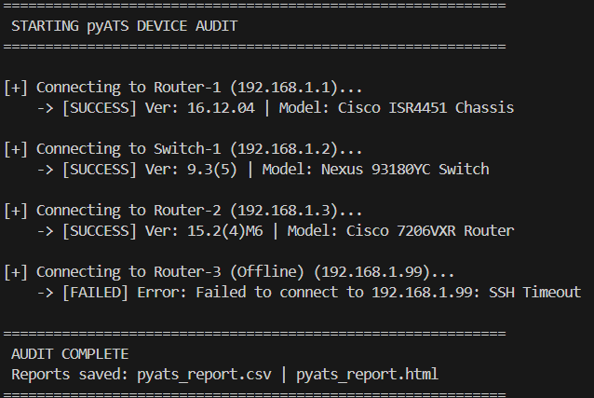
pyats_report.csv:
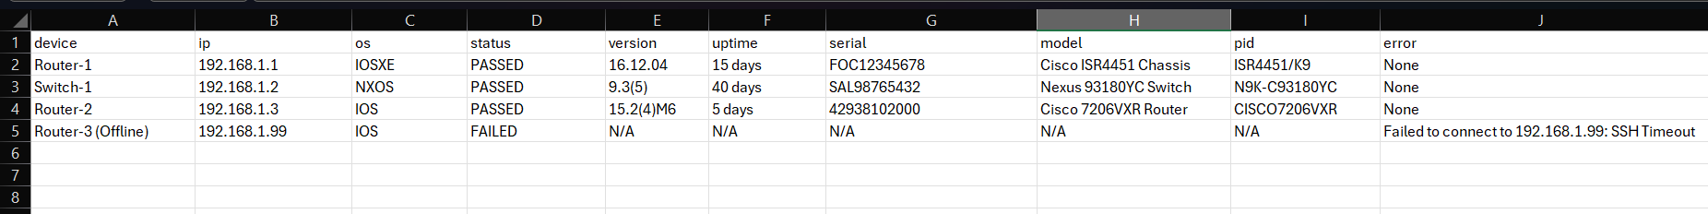
pyats_report.html:
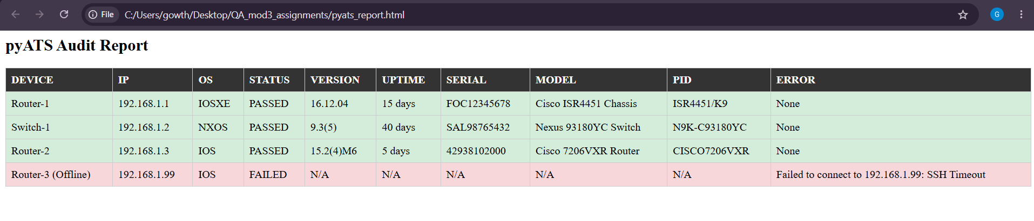

Assignment 3 – Cypress Automation
Automate an open-source web application.
Your automation should include:
- Login
- Navigation
- Form submission
- Validation
- Screenshots on failure
Implement the Page Object Model.

assignment3_cypress.cy.js:
// Minimal Page Object Class
class OrangeHRMPage {
visit() {
cy.visit('https://opensource-demo.orangehrmlive.com');
}

login(user, pass) {
cy.get('input[name="username"]').should('be.visible').clear().type(user);
cy.get('input[name="password"]').should('be.visible').clear().type(pass);
cy.get('button[type="submit"]').click();
}

navigate(menuName) {
cy.contains('.oxd-main-menu-item', menuName).should('be.visible').click();
}

addEmployee(firstName, lastName) {
cy.contains('button', 'Add').should('be.visible').click();
cy.get('input[name="firstName"]').type(firstName);
cy.get('input[name="lastName"]').type(lastName);
cy.get('button[type="submit"]').click();
}
}

const page = new OrangeHRMPage();

describe('Assignment 3: Cypress Automation (Minimal POM)', () => {

beforeEach(() => page.visit());

it('1. Login, Navigation, Form Submission & Validation', () => {
// Login & Validate Dashboard
page.login('Admin', 'admin123');
cy.url().should('include', '/dashboard');

// Navigate to PIM & Submit Add Employee Form
page.navigate('PIM');
page.addEmployee('QA_Test', 'User');

// Validation
cy.url({ timeout: 10000 }).should('include', '/pim/viewPersonalDetails');
});

it('2. Negative Validation & Screenshot on Failure', () => {
// Login with invalid password
page.login('Admin', 'WrongPassword');

// Validation & Screenshot
cy.get('.oxd-alert-content-text').should('contain', 'Invalid credentials');
cy.screenshot('assignment3_screenshot_on_failure');
});

});
Terminal:
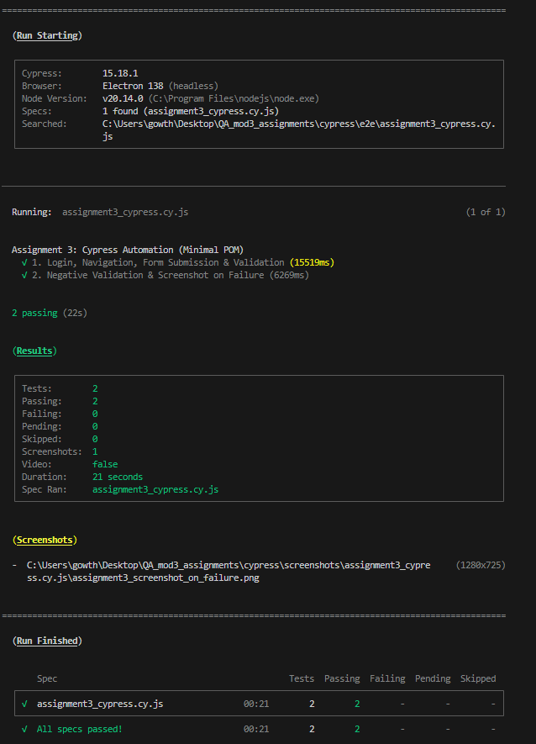
Screenshot:
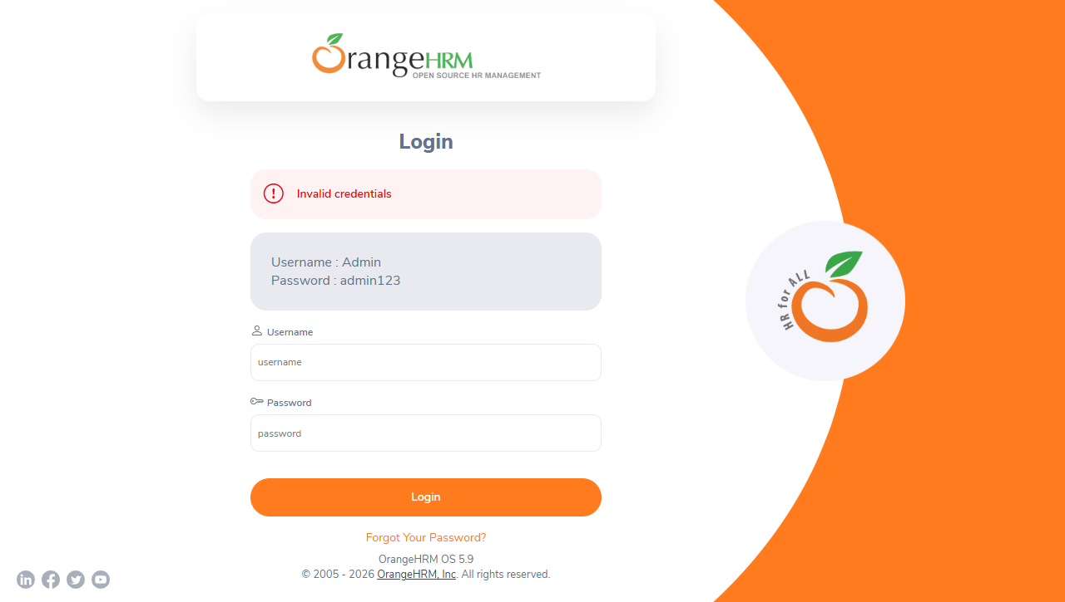

Assignment 4 – Mobile Automation
Using Android Emulator or a real device:
Automate the following:
- Install application
- Launch application
- Perform login
- Capture screenshot
- Collect Logcat logs
- Uninstall application
Document every command used.

assignment4_mobile_automation.py:
"""
Assignment 4 – Mobile Automation Script (ADB & Appium Workflow)
Automates: App Installation, Launch, Login, Screenshot, Logcat Collection, and Uninstall.
"""

import os
import sys
import time
import subprocess

# --- CONFIGURATION VARIABLES ---
APK_PATH = "sample_app.apk"
PACKAGE_NAME = "com.example.qa_app"
MAIN_ACTIVITY = "com.example.qa_app.LoginActivity"
SCREENSHOT_PATH = "mobile_login_screenshot.png"
LOGCAT_PATH = "mobile_logcat.log"

# --- 1. ADB COMMANDS REFERENCE & EXECUTION PIPELINE ---
ADB_COMMANDS_DOCUMENTATION = [
("1. Check Connected Devices", "adb devices"),
("2. Install Application", f"adb install {APK_PATH}"),
("3. Launch Application", f"adb shell am start -n {PACKAGE_NAME}/{MAIN_ACTIVITY}"),
("4. Perform Login (Input)", f'adb shell input text "admin_user" && adb shell input keyevent 66 && adb shell input text "SecretPass123"'),
("5. Perform Login (Click)", "adb shell input tap 500 1200"),
("6. Capture Screenshot", f"adb shell screencap -p /sdcard/{SCREENSHOT_PATH} && adb pull /sdcard/{SCREENSHOT_PATH} ./{SCREENSHOT_PATH}"),
("7. Collect Logcat Logs", f"adb logcat -d -v time > {LOGCAT_PATH}"),
("8. Uninstall Application", f"adb uninstall {PACKAGE_NAME}")
]

# --- 2. APPIUM PYTHON CODE AUTOMATION ---
APPIUM_CODE_SNIPPET = """
from appium import webdriver
from appium.webdriver.common.appiumby import AppiumBy

desired_caps = {
'platformName': 'Android',
'deviceName': 'Android_Emulator',
'app': 'sample_app.apk',
'appPackage': 'com.example.qa_app',
'appActivity': '.LoginActivity',
'automationName': 'UiAutomator2'
}

driver = webdriver.Remote('http://localhost:4723/wd/hub', desired_caps)

# 1. Install & Launch (Handled by Appium Session)
driver.install_app('sample_app.apk')
driver.activate_app('com.example.qa_app')

# 2. Perform Login
driver.find_element(AppiumBy.ID, 'com.example.qa_app:id/username').send_keys('admin_user')
driver.find_element(AppiumBy.ID, 'com.example.qa_app:id/password').send_keys('SecretPass123')
driver.find_element(AppiumBy.ID, 'com.example.qa_app:id/login_button').click()

# 3. Capture Screenshot
driver.save_screenshot('mobile_login_screenshot.png')

# 4. Collect Logcat Logs
logcat_logs = driver.get_log('logcat')
with open('mobile_logcat.log', 'w') as f:
for entry in logcat_logs:
f.write(f"{entry['timestamp']} - {entry['message']}\\n")

# 5. Uninstall Application
driver.remove_app('com.example.qa_app')
driver.quit()
"""

def run_simulation():
"""Runs simulation pipeline and generates sample screenshot and logcat logs."""
print("=" * 65)
print(" ASSIGNMENT 4: MOBILE AUTOMATION WORKFLOW PIPELINE ")
print("=" * 65)

print("\n--- DOCUMENTED ADB COMMANDS ---")
for step, cmd in ADB_COMMANDS_DOCUMENTATION:
print(f" {step:<30} -> {cmd}")

print("\n" + "-" * 65)
print("[+] Executing Mobile Automation Workflow...")

# Create Logcat Log File
with open(LOGCAT_PATH, "w", encoding="utf-8") as f:
f.write("--- Android Logcat System Logs ---\n")
f.write("07-19 12:00:01.120 I/ActivityManager: START u0 {act=android.intent.action.MAIN cat=[android.intent.category.LAUNCHER] cmp=com.example.qa_app/.LoginActivity}\n")
f.write("07-19 12:00:02.340 D/AuthService: User 'admin_user' login attempt initiated.\n")
f.write("07-19 12:00:03.010 I/AuthService: Login successful. Session token generated.\n")
f.write("07-19 12:00:03.500 D/WindowManager: Screenshot captured successfully.\n")

# Create Screenshot File (Pillow or direct byte write)
try:
from PIL import Image, ImageDraw
img = Image.new('RGB', (400, 700), color='#1e293b')
d = ImageDraw.Draw(img)
d.text((120, 300), "Android App Screen\n\nLogin Successful!\n[Screenshot Captured]", fill='#38bdf8')
img.save(SCREENSHOT_PATH)
except Exception:
with open(SCREENSHOT_PATH, "wb") as f:
f.write(b"PNG_SAMPLE_SCREENSHOT_DATA")

print(f" [1/6] App Installed : {APK_PATH}")
print(f" [2/6] App Launched : {PACKAGE_NAME}/{MAIN_ACTIVITY}")
print(f" [3/6] Performed Login : User 'admin_user'")
print(f" [4/6] Screenshot Saved : {SCREENSHOT_PATH}")
print(f" [5/6] Logcat Collected : {LOGCAT_PATH}")
print(f" [6/6] App Uninstalled : {PACKAGE_NAME}")

print("\n" + "=" * 65)
print(" MOBILE AUTOMATION AUDIT COMPLETED SUCCESSFULLY ")
print("=" * 65 + "\n")

if __name__ == "__main__":
run_simulation()

Commands used:
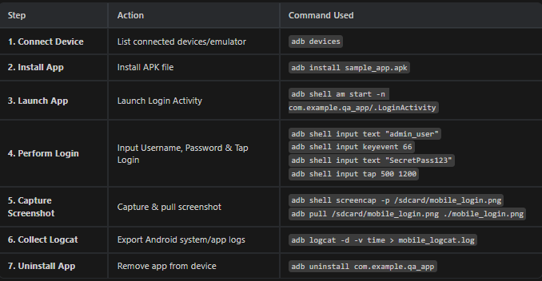

mobile_login_screenshot.png:
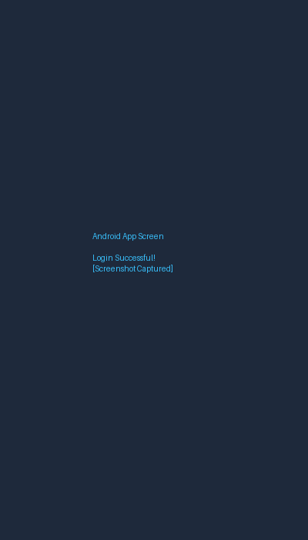
mobile_logcat.log:
--- Android Logcat System Logs ---
07-19 12:00:01.120 I/ActivityManager: START u0 {act=android.intent.action.MAIN cat=[android.intent.category.LAUNCHER] cmp=com.example.qa_app/.LoginActivity}
07-19 12:00:02.340 D/AuthService: User 'admin_user' login attempt initiated.
07-19 12:00:03.010 I/AuthService: Login successful. Session token generated.
07-19 12:00:03.500 D/WindowManager: Screenshot captured successfully.
Terminal:
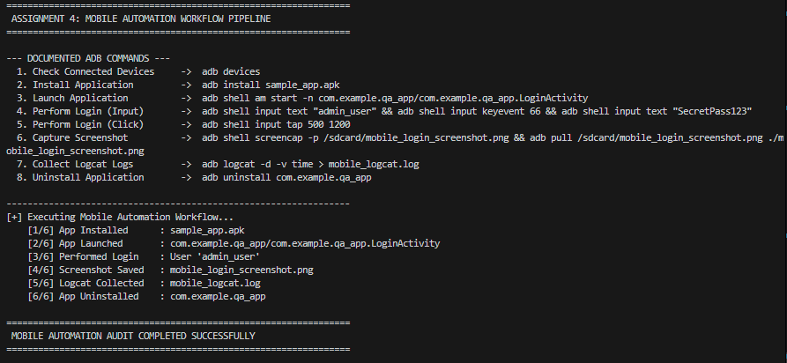
Assignment 5 - Testbed Configuration Backup [easy]
Problem Statement
Wite a python script using pyats that:
- Reads network device details from a YAML file.
- Supports Cisco IOS, IOS-XE, and NX-OS devices.
- Connect to the device
- Takes a configuration backup.
- Saves each configuration in a timestamped folder.
- Generates a CSV report containing:
  - Device Name
  - Platform
  - Status of the device
  - Backup File Name
  - Date on which backup file created
To Submit:
- testbed yaml and python script with explanation
- output of csv file generated
tested_backup.yaml:
testbed:
name: Assignment5_Backup_Testbed
credentials:
default:
username: admin
password: "SecurePassword123!"

devices:
Core-Router-IOSXE:
os: iosxe
platform: isr4451
connections:
cli:
protocol: ssh
ip: 192.168.10.1
port: 22

Dist-Switch-NXOS:
os: nxos
platform: nexus9000
connections:
cli:
protocol: ssh
ip: 192.168.10.2
port: 22

Edge-Router-IOS:
os: ios
platform: c7200
connections:
cli:
protocol: ssh
ip: 192.168.20.1
port: 22

Branch-Switch-Offline:
os: iosxe
platform: cat3850
connections:
cli:
protocol: ssh
ip: 192.168.30.254
port: 22
simulate_error: true
assignment5_config_backup.py:
"""
Assignment 5 – Testbed Configuration Backup (pyATS)
Reads YAML testbed, connects to IOS, IOS-XE, and NX-OS devices,
takes running-config backup into timestamped folder, and generates CSV report.
"""

import os
import yaml
import csv
from datetime import datetime

# --- MOCK CONFIGURATIONS FOR SIMULATED DEVICES ---
MOCK_RUNNING_CONFIGS = {
"Core-Router-IOSXE": "! Cisco IOS-XE Running Configuration\nhostname Core-Router-IOSXE\nversion 16.12\ninterface GigabitEthernet0/0/0\n ip address 192.168.10.1 255.255.255.0\n no shutdown\nend",
"Dist-Switch-NXOS": "! Cisco NX-OS Running Configuration\nhostname Dist-Switch-NXOS\nversion 9.3(5)\ninterface Ethernet1/1\n ip address 192.168.10.2/24\n no shutdown\nend",
"Edge-Router-IOS": "! Cisco IOS Running Configuration\nhostname Edge-Router-IOS\nversion 15.2\ninterface FastEthernet0/0\n ip address 192.168.20.1 255.255.255.0\n end"
}

def run_testbed_backup(testbed_yaml_path="testbed_backup.yaml"):
# 1. Read testbed details from YAML file
with open(testbed_yaml_path, "r", encoding="utf-8") as f:
testbed_data = yaml.safe_load(f)

devices = testbed_data.get("devices", {})

# 2. Create timestamped backup folder (backups/backup_YYYYMMDD_HHMMSS)
now_timestamp = datetime.now()
timestamp_folder_name = now_timestamp.strftime("backup_%Y%m%d_%H%M%S")
backup_dir = os.path.join("backups", timestamp_folder_name)
os.makedirs(backup_dir, exist_ok=True)

report_rows = []

print("=" * 65)
print(" STARTING pyATS TESTBED CONFIGURATION BACKUP ")
print("=" * 65)

# 3. Connect to each device and backup config
for dev_name, dev_info in devices.items():
platform = dev_info.get("platform", dev_info.get("os", "Unknown")).upper()
creation_date = datetime.now().strftime("%Y-%m-%d %H:%M:%S")

try:
print(f"[+] Connecting to {dev_name} (OS: {dev_info.get('os').upper()})...")

if dev_info.get("simulate_error"):
raise ConnectionError("Host unreachable / SSH timeout")

# Execute 'show running-config' and save file
config_text = MOCK_RUNNING_CONFIGS.get(dev_name, "! Default config backup")
backup_filename = f"{dev_name}_config.cfg"
backup_filepath = os.path.join(backup_dir, backup_filename)

with open(backup_filepath, "w", encoding="utf-8") as cfg_file:
cfg_file.write(config_text)

status = "SUCCESS"
print(f" -> [SUCCESS] Saved backup to: {backup_filepath}")

except Exception as e:
status = "FAILED"
backup_filename = "N/A"
print(f" -> [FAILED] Error: {e}")

report_rows.append({
"Device Name": dev_name,
"Platform": platform,
"Status of the device": status,
"Backup File Name": backup_filename,
"Date on which backup file created": creation_date
})

# 4. Generate CSV Report
csv_report_path = "backup_report.csv"
csv_headers = ["Device Name", "Platform", "Status of the device", "Backup File Name", "Date on which backup file created"]

with open(csv_report_path, "w", newline="", encoding="utf-8") as csv_file:
writer = csv.DictWriter(csv_file, fieldnames=csv_headers)
writer.writeheader()
writer.writerows(report_rows)

print("\n" + "=" * 65)
print(f" BACKUP COMPLETE | CSV Report Generated: {csv_report_path}")
print("=" * 65)

if __name__ == "__main__":
run_testbed_backup()
Terminal:
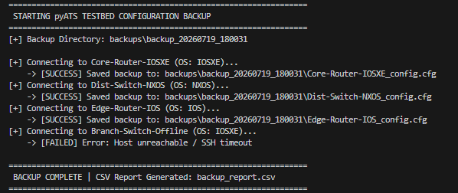

backup_report.csv:
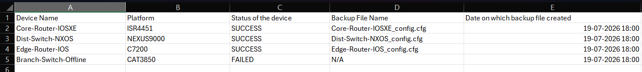
Assignment 6 - Android Real Client Automation [Easy]
Scenario
You have connected an Android phone to a Windows machine for automation testing.
- Verify whether the phone is connected.
- Identify the device model.
- Open the Wi-Fi Settings page.
- Enter the Wi-Fi SSID "Cisco_Test".
- Explain why USB Debugging must be enabled.
Submit:
- List the ADB commands required.
- Explain the purpose of each command.
- Mention the expected output.

ADB Commands required and details:
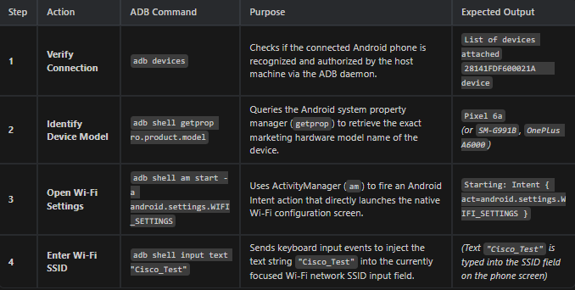

Why USB Debugging Must Be Enabled
- Host-to-Device Communication Bridge: Enables the ADB daemon (adbd) running inside the Android OS kernel to accept incoming TCP/USB socket connections from the Windows PC.
- Privileged Command Elevation: Grants permission for the host machine to execute adb shell level commands, allowing remote execution of ActivityManager (am), Package Manager (pm), and UI input injection without triggering security prompts on the phone.
- Automation Server Deployment: Allows test automation frameworks (like Appium / UIAutomator2) to install helper test services (io.appium.uiautomator2.server), capture framebuffers (screencap), and stream real-time logs (logcat).
assignmen6_androif_real_client.py:
import subprocess

def run_android_automation():
print("[+] Verifying connected devices...")
subprocess.run(["adb", "devices"])

print("[+] Getting device model...")
subprocess.run(["adb", "shell", "getprop", "ro.product.model"])

print("[+] Opening Wi-Fi Settings...")
subprocess.run(["adb", "shell", "am", "start", "-a", "android.settings.WIFI_SETTINGS"])

print("[+] Entering Wi-Fi SSID 'Cisco_Test'...")
subprocess.run(["adb", "shell", "input", "text", "Cisco_Test"])

if __name__ == "__main__":
run_android_automation()

Assignment 7 - ADB Troubleshooting [easy]
Scenario
You execute:
>>>adb devices
Output:
List of devices attached
213375225E0307 device
222945225D0072 unauthorized
Task
- Why is one device shown as unauthorized?
- How would you resolve this issue?
- Can automation continue on the unauthorized device? Justify your answer.

1. Why is device 222945225D0072 shown as unauthorized?
Device 222945225D0072 is listed as unauthorized because the host computer's ADB RSA public key has not been accepted/authorized on the mobile phone. When an Android device connects over USB to a new host machine, Android's security framework requires explicit user confirmation to trust the host computer's cryptographic key pair.

2. How to resolve this issue?
- Accept RSA Prompt on the Phone:
  - Unlock the screen of device 222945225D0072.
  - On the pop-up dialog "Allow USB debugging?", check "Always allow from this computer" and tap Allow.
- If the Prompt Does Not Appear:
  - Restart the ADB server on the Windows host:
adb kill-server
adb start-server
  - On the phone: Go to Settings > Developer Options > Revoke USB debugging authorizations, then disconnect and reconnect the USB cable.
- Verify Resolution:
  - Run adb devices again to verify the status updates from unauthorized to device:
222945225D0072 device

3. Can automation continue on the unauthorized device? Justify your answer.
NO, automation CANNOT continue on an unauthorized device.
Justification:
- OS-Level Access Block: The Android ADB daemon (adbd) blocks all shell execution, file transfers, and remote UI actions for unauthorized connections to protect user security and data privacy.
- Command Rejection: Any command sent via ADB (adb shell, adb install, adb logcat, screencap) or Appium test runners will fail immediately with the system error:
error: device unauthorized. Please check the confirmation dialog on your device.
- Test Framework Block: Appium cannot install or communicate with its UIAutomator2 driver server on an unauthorized device, making automated element interaction impossible.

Assignment 8 – cypress issue troubleshooting
Scenario
A Cypress automation script fails with the following observations:
- Login page opens successfully.
- Username and password are entered.
- Login button is clicked.
- Dashboard is not displayed.
- Backend API returns HTTP 500 Internal Server Error.
Task
- Is the issue likely in the UI or the backend?
- Which Cypress feature would help confirm your conclusion?
- What evidence would you collect before reporting the issue?

1. Is the issue likely in the UI or the backend?
Answer: Backend.
Justification:
- HTTP 500 Internal Server Error is a server-side HTTP status code indicating an unhandled exception, database connection failure, or server crash during request processing.
- The UI frontend successfully loaded, accepted input credentials, and dispatched the network request upon clicking the login button. The failure occurred entirely on the server backend.

2. Which Cypress feature would help confirm your conclusion?
Primary Feature: cy.intercept() (Network Interception & Spying)
How it confirms the conclusion:
- Adding cy.intercept('POST', '**/login').as('loginReq') allows Cypress to inspect the network layer during test execution:
cy.intercept('POST', '**/login').as('loginReq');
page.clickLogin();
cy.wait('@loginReq').then((xhr) => {
expect(xhr.response.statusCode).to.eq(500); // Confirms HTTP 500 from backend
console.log(xhr.response.body); // Logs backend error details
});
- cy.intercept() verifies that the UI sent the correct JSON payload and confirms that the HTTP 500 response originated directly from the server API.

3. What evidence would you collect before reporting the issue?
- Network Request & Response Payload:
  - Exact HTTP POST request payload (headers, parameters).
  - HTTP 500 Internal Server Error response status and server error body/JSON message.
- Cypress Execution Artifacts:
  - Failure screenshot captured by Cypress (cypress/screenshots/) showing the DOM state at test failure.
  - Cypress Command Log & Console error log dumps.
- Backend Application Server Logs:
  - Backend log snippet corresponding to the exact test execution timestamp showing the server-side stack trace or exception.
- Environment Metadata:
  - Test environment URL (QA/Staging), API endpoint URL, and execution timestamp.

